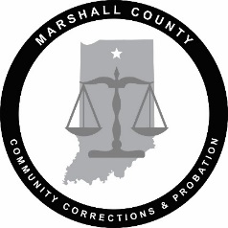

**Marshall County Employment Opportunity**

**Department: Marshall County Probation**

**Position: Adult Probation Officer**

**Job Category: Professional**

**Status: Full-Time (35-hour work week)**

Responsibilities: Serves as a Probation Officer responsible for conducting Presentence Investigation Reports and reports for the court, making sentencing recommendations to the court, utilizing evidence-based strategies to promote behavioral change, and supervising clients for enforcement of conditions of supervision. Evaluating the risks and needs of the client. Coordination and collaboration with treatment professionals and other community entities.

Qualifications: The position requires a bachelor’s degree in criminal justice or related field. The individual must be 21 years of age and have a valid driver’s license. Be a Certified Indiana Probation Officer or able to obtain said certification within six months of employment. Prefer experience/training in probation, community corrections, criminal justice, criminology, social work, psychology, sociology, and/or case management. Applicants must have good communication skills, **possess excellent organizational skills, and can work with confidential information in a professional and ethical manner.** Familiarity with the Odyssey Court System and Incite is desired, but not mandatory. **A criminal background check and a pre-employment drug screen will be required.**

Rate of pay is based on the Indiana Probation Officer Salary Schedule.

**Interested candidates for this position need to submit their resume and application** by **July 11, 2025**. Applications can be located online at [www.co.marshall.in.us](http://www.co.marshall.in.us).

Please forward all applications and resumes to:

**Marshall County Government**

**Human Resource Office**

**Marshall County Building, Room 300,**

**Plymouth, Indiana 46563.**

***Marshall County is an Equal Opportunity Employer***