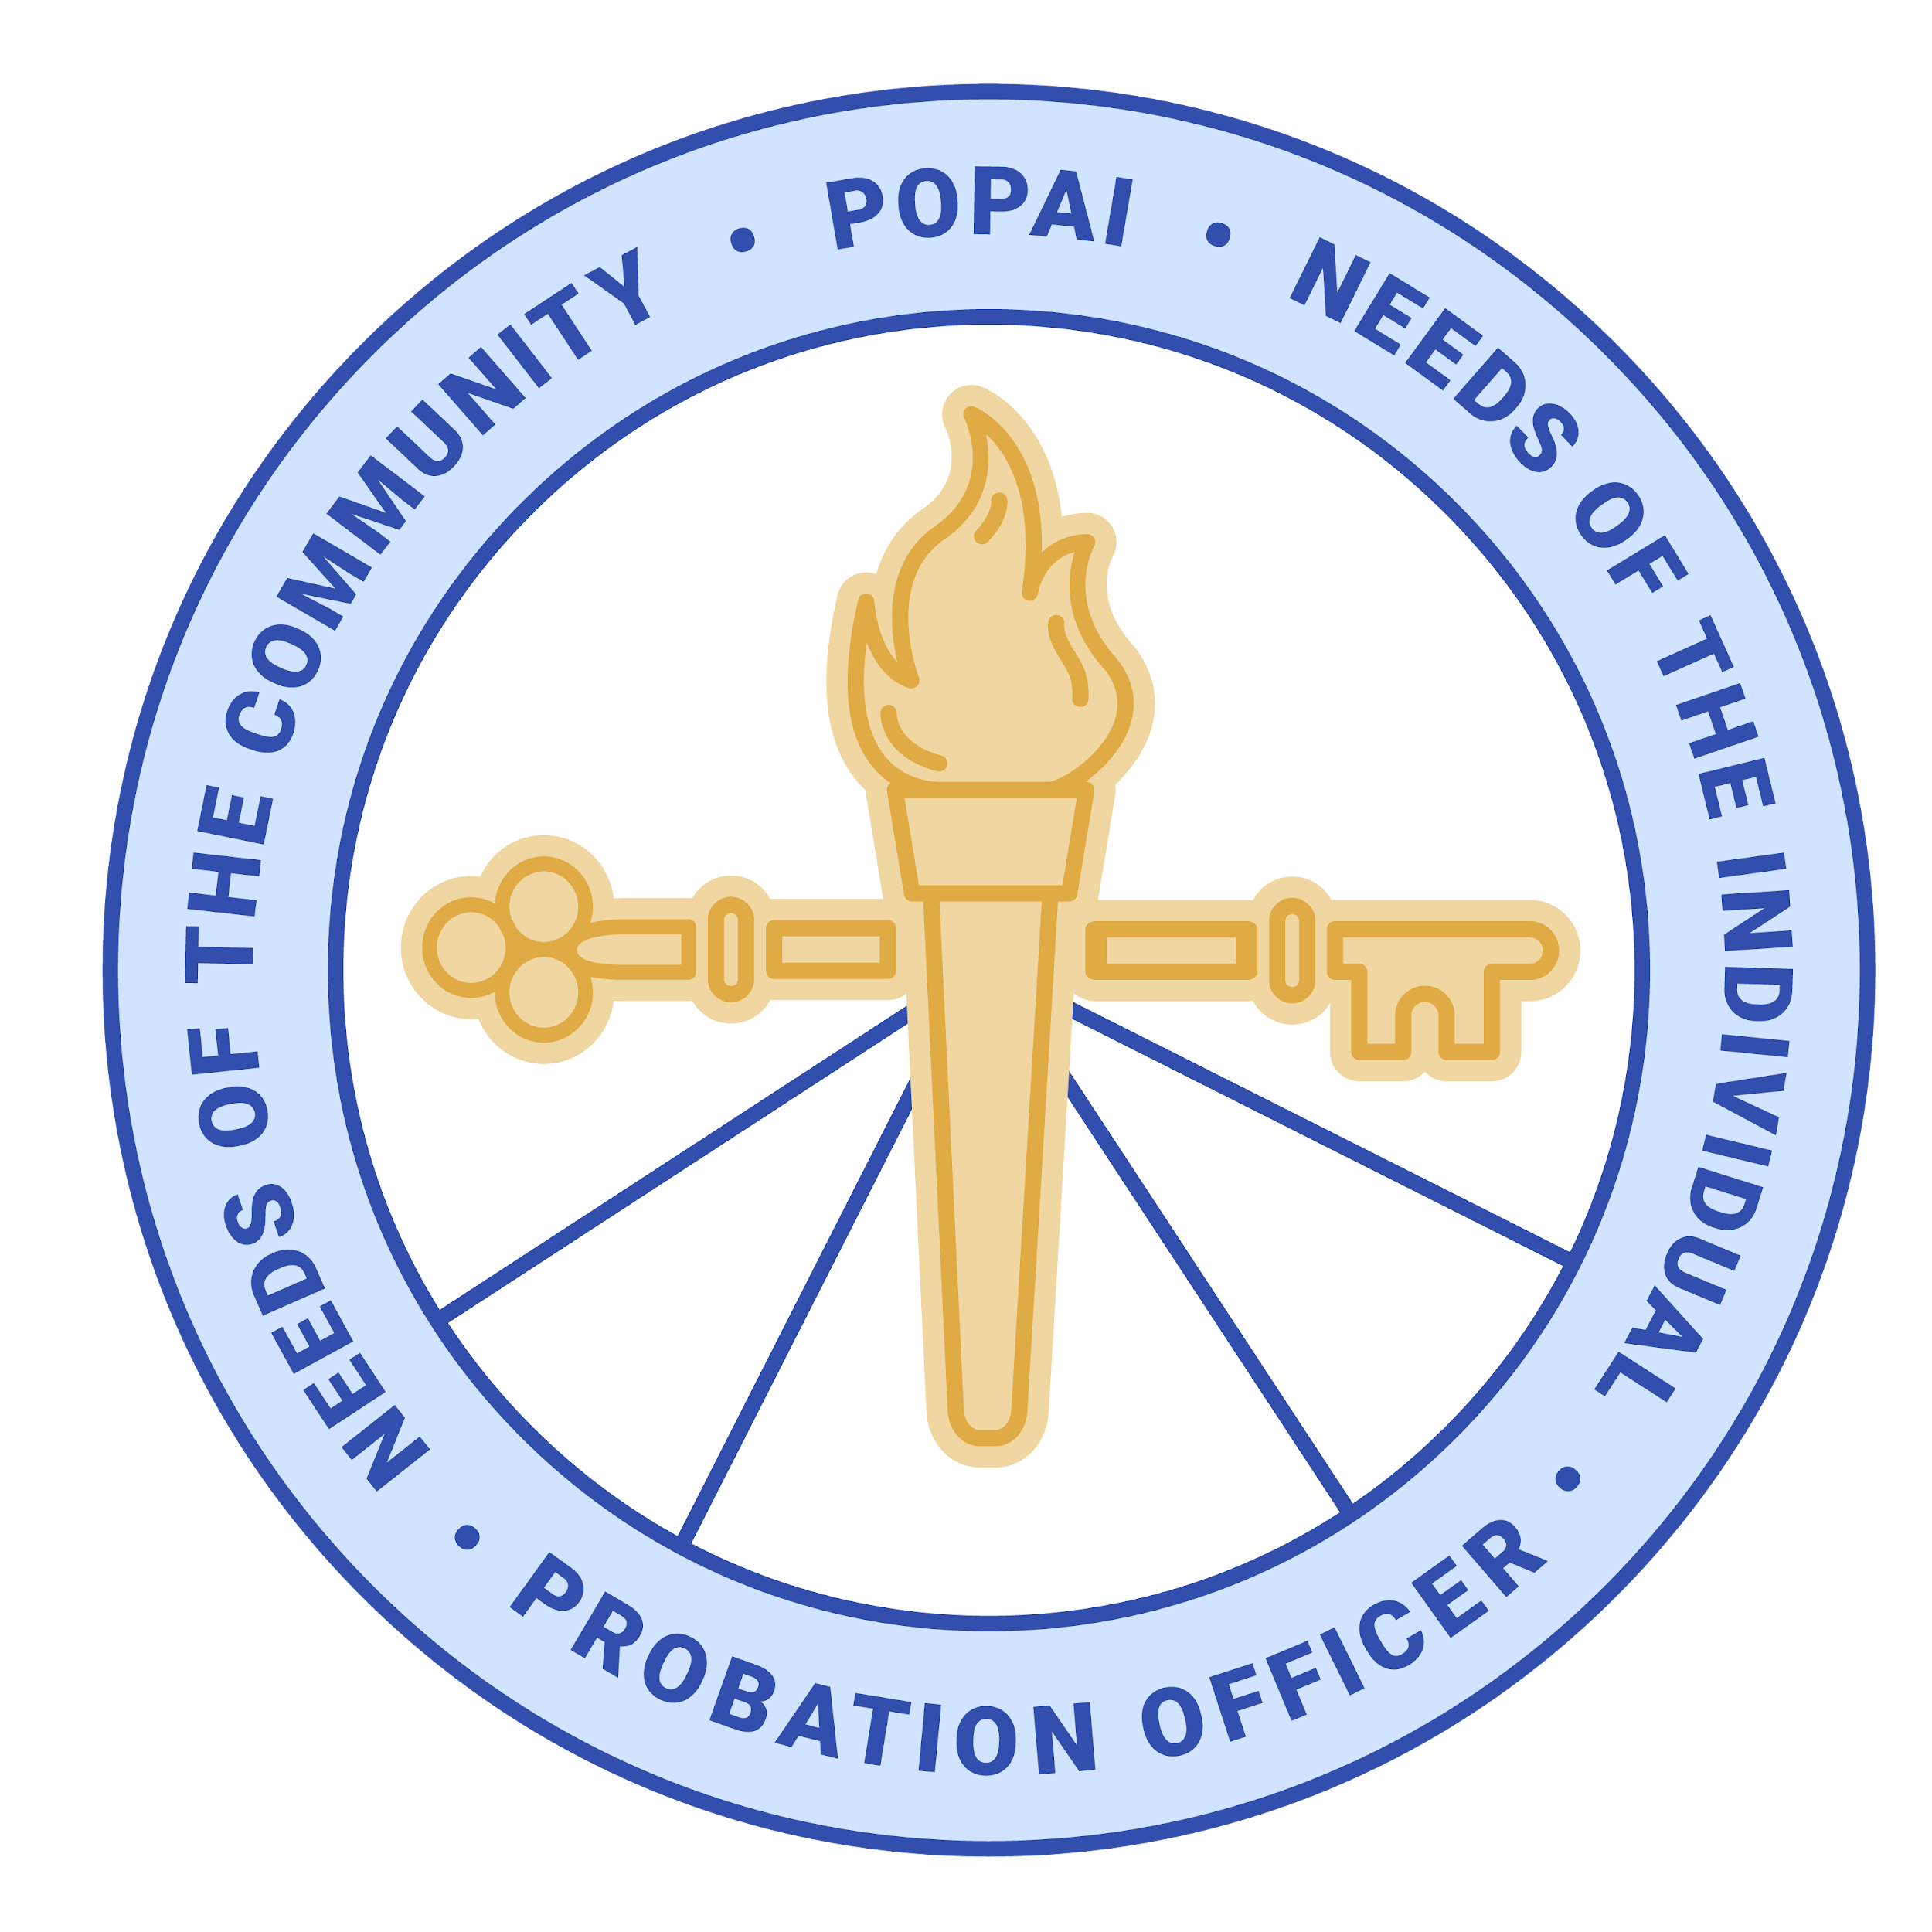

INTENT TO RUN FOR ELECTED OFFICE

Position Desired: Indicate the office for which you wish to run. All offices are 2-year terms.

VICE-PRESIDENT
TREASURER
DISTRICT ONE | Jasper, Lake, LaPorte, Newton, Porter, Pulaski, and Starke counties
DISTRICT THREE | Carroll, Cass, Clinton, Elkhart, Fulton, Howard, Kosciusko, Marshall, Miami, St. Joseph, Tipton, and Wabash counties
DISTRICT FIVE | Boone, Hancock, Hamilton, Hendricks, Johnson, Marion, Morgan, and Shelby counties
DISTRICT SIX | Benton, Clay, Fountain, Greene, Montgomery, Owen, Parke, Putnam, Sullivan, Tippecanoe, Vermillion, Vigo, Warren, and White
DISTRICT SEVEN | Bartholomew, Brown, Clark, Crawford, Dearborn, Decatur, Floyd, Harrison, Jackson, Jefferson, Jennings, Lawrence, Monroe, Ohio, Orange, Ripley, Scott, Switzerland, and Washington counties
AT-LARGE #1

Probation Officer Name:
Present Position (title):

Probation Department:
Work Address (with zip):
Email Address:
Work Phone:
Cell Phone (not shared):

Years working as an Indiana Probation Officer:

Education – List institutions, dates attended, and degrees awarded.

Professional/Community Activities – List memberships/organizations, offices held, and awards received.

Why do you wish to hold this position? What do you hope to accomplish as a POPAI Board Member?

Discuss the issues you view as most important to probation in Indiana.

POPAI BOARD MEMBER COMMITMENTS AND OBLIGATIONS
The list below describes the minimum level of commitment that Board members are asked to make to this professional organization. Before running for office, POPAI Members should be aware of the obligations and be able to commit to fulfilling these obligations.

MEETING ATTENDANCE:
Attendance at POPAI Board meetings is vitally important to the organization. Board members are expected to attend the scheduled meetings (typically) in person with minimal absences. The Board usually meets on the second Wednesday of each month, 10:30 AM – 1:30 PM. In 2025, we alternated between Hendricks County Probation in Danville and Johnson County Probation in Franklin. We have been able to offer Zoom connections at most meetings.
Possible exceptions:
- Board meeting is held at the POPAI Management Institute, usually in February, March, or April
- Board meeting is held during the Justice Services Conference, usually in April or May
- Board meeting is held on Friday of the POPAI Fall training in French Lick after the conference ends. It is important that you stay for this meeting as it will be your first Board meeting upon your election.
- Some POPAI Board meetings may be held via video conference due to weather or other reasons.

COMMITTEE WORK
Board members must work on at least one POPAI Committee. Standing committees: Election; Awards and Recognition; Technology; Education; Legislation; Membership.

POPAI CONFERENCES/TRAININGS ATTENDANCE
POPAI sponsors two training conferences per year: the POPAI Management Institute/Chief PO Summit and the Annual Fall Conference. Board members are expected to make every effort to participate in these conferences/trainings. Board members are asked to assist at the registration table for the Fall Conference (when possible). [Note: Board members who have a financial need may request a waiver of tuition for POPAI conferences.]

CHIEF PROBATION OFFICER APPROVAL
If you are not the Chief Probation Officer of your department, you must include as an attachment an email or memo from the Chief PO approving your attendance at in-person monthly POPAI Board meetings; your participation in at least one POPAI standing committee; and verifying your ability to attend POPAI trainings/conferences during your elective term.

THANK YOU FOR YOUR INTEREST IN SERVING PROBATION IN THE STATE OF INDIANA.

All forms and supporting documentation must be emailed by 12/29/2025 at or before noon Eastern Time to

Josh Herman, Elections Chair

Email: elections@gopopai.org

