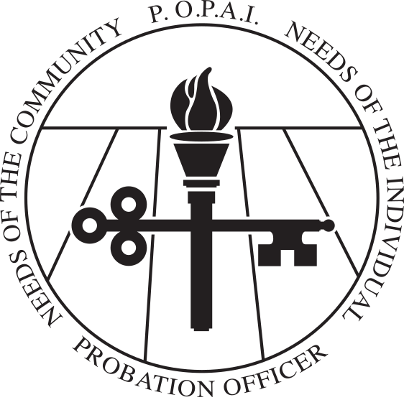

INTENT TO RUN FOR ELECTED OFFICE
SEPTEMBER 2022 POPAI ELECTION

Position Desired: Circle the office for which you wish to run. All offices are 2-year terms.

PRESIDENT

SECRETARY

DISTRICT TWO Adams, Allen, DeKalb, Huntington, LaGrange, Noble, Steuben, Wells, and
Whitley

DISTRICT FOUR Blackford, Delaware, Fayette, Franklin, Grant, Henry, Jay, Madison, Randolph, Rush, Union, and Wayne

DISTRICT SIX Benton, Clay, Fountain, Greene, Montgomery, Owen, Parke, Putman, Sullivan,
Tippecanoe, Vermillion, Vigo, Warren, and White

DISTRICT EIGHT Daviess, Dubois, Gibson, Knox, Martin, Perry, Pike, Posey, Spencer, Vanderburgh, and Warrick

Probation Officer Name:
Present Position (title):

Probation Department:
Work Address (with zip):
Work Phone:
Cell Phone (not shared):

Years working as Indiana Probation Officer:

Education – List institutions, dates attended, and degrees awarded.

Professional/Community Activities – List memberships/organizations, offices held, and awards received.

Why do you wish to hold this position? What do you hope to accomplish as a POPAI Board Member?

Discuss the issues you view as most important to probation in Indiana.

POPAI BOARD MEMBER COMMITMENTS AND OBLIGATIONS
The list below describes the minimum level of commitment that Board members are asked to make to this professional organization. Before running for office, POPAI Members should be aware of the obligations and be able to make a commitment to fulfill these obligations.

MEETING ATTENDANCE:
Attendance at POPAI Board meetings is vitally important to the organization. Board members are expected to attend the scheduled meetings (typically) in person with minimal absences. The Board usually meets the second Wednesday of each month in Indianapolis, 10:30 AM – 1:30 PM. Possible exceptions:
- Board meeting is held at the POPAI Management Institute usually in February, March, or April
- Board meeting is held during the Justice Services Conference usually in April or May
- Board meeting is held on Friday of POPAI Fall training in French Lick after the conference ends. It is important that you stay for this meeting at it would be your first Board meeting upon your election.
- Some POPAI Board meetings may be held via video conference due to weather or other reasons.

COMMITTEE WORK
Board members must work on at least one POPAI Committee. Standing committees: Election; Awards and Recognition; Technology; Education; Legislation; Membership.

POPAI CONFERENCES/TRAININGS ATTENDANCE
POPAI sponsors two training conferences per year: POPAI Management Institute/Chief PO Summit and Annual Fall Conference. Board members are expected to make every effort to participate in these conferences/trainings. Board members are asked to assist at the registration table for the Fall Conference (when possible). [Note: Board members that have a financial need may request waiver of tuition for POPAI conferences.]

CHIEF PROBATION OFFICER APPROVAL
If you are not the Chief Probation Officer of your department, you must include as an attachment an email or memo from the Chief PO approving your attendance at in-person monthly POPAI Board meetings; your participation in at least one POPAI standing committee; and verifying your ability to attend POPAI trainings/conferences during your elective term.

THANK YOU FOR YOUR INTEREST IN SERVING PROBATION IN THE STATE OF INDIANA.

All forms emailed by 12:00 p.m. on July 25, 2022 to

Rebecca Schrock
Hendricks County Probation
101 W. Marion Street
Danville, IN 46122
Email: rschrock@co.hendricks.in.us

